Assignment-23.1:

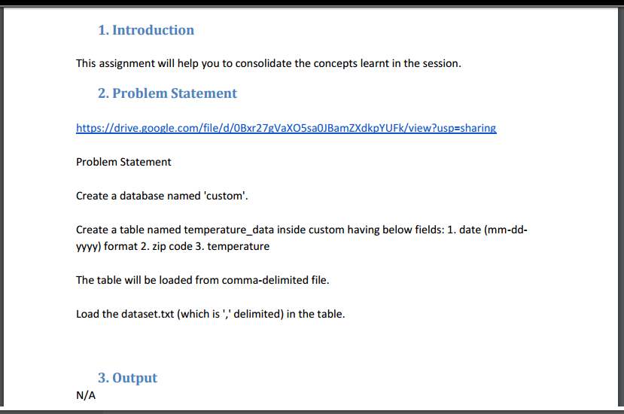

Database named custom is created.

C:\Users\612792\Desktop\3.4\23.1 data.png

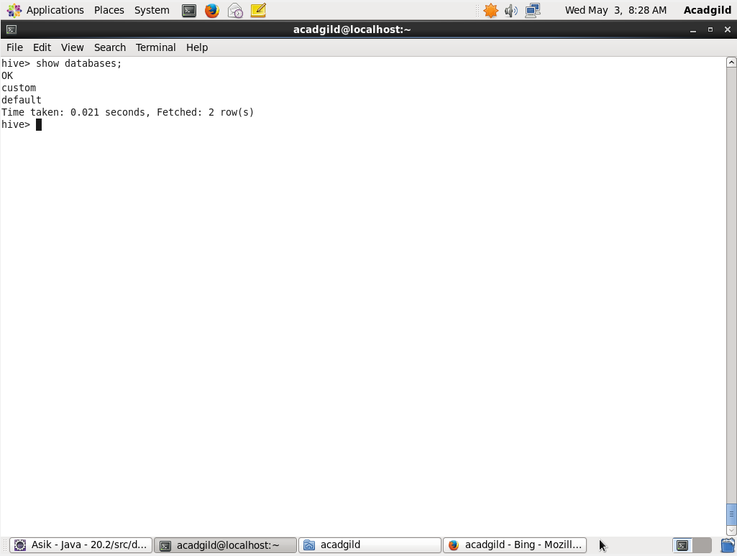

In the below screenshot, the custom database is used. Then a table named temperature_data is created using the create command. The data is loaded from the local system. The entire contents of the table is displayed.

